

# Aspera F42

## Type of device: Mobile

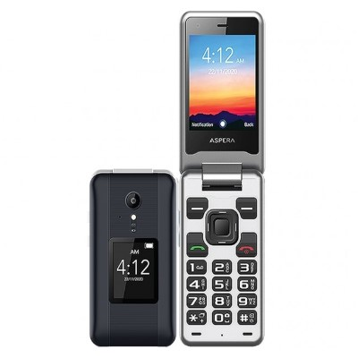

Actual Display Size : 2.8 inches

Button Type : Physical Keypad

Network Capability : 3G,4G

Year of Release : 2020

Average Price : $102 as of 09 06 2021

## Accessibility Features:

### Cognitive

* Copy and Paste
* GPS
* Screen Timeout Disabled
* Simple Instructions
* Simple Reminders

Voice Notes

### Hearing Impairment and Deaf

* Bluetooth or Wi-Fi
* Front Facing Camera
* Hearing Aid Microphone Coupling
* Hearing Aid Telecoil Coupling
* Text Messaging/SMS
* Vibrating Alerts - Adjustable

Visual Alerts - Incoming Calls

### Vision

* Bluetooth or Wi-Fi
* Brightness Adjustable
* Key Marker – Raised '5'
* Key Numbers - Standard Layout
* Key Press - Vibration or Click
* Personalised Shortcuts

Text Size Adjustable

### Speech

* Bluetooth or Wi-Fi
* Messaging Options - MMS

Predictive Text

### Physical

* Bluetooth or Wi-Fi
* Guarded/Recessed Keys
* Headset - plug connected
* Physical Dialling Keys
* Predictive Text

Speaker-phone option

## How and where to get it from?

You can buy this phone from [Australia Post](https://auspost.com.au/shop/product/aspera-f42-4g-flip-mobile-phone-graphite-73407), [Harvey Norman](https://www.harveynorman.com.au/catalogsearch/result/?q=aspera+f42), [Mobileciti](https://www.mobileciti.com.au/catalogsearch/result/?q=aspera+f42), [Domayne](https://www.domayne.com.au/catalogsearch/result/?q=aspera+f42), [Kogan](https://www.kogan.com/au/buy/aspera-f42-black-4g-flip-phone-09351424000253/), [Allphones](https://www.allphones.com.au/aspera-f42-flip-phone-4g-lte-2mp-titanium), and other retailers.

## More information is available on:

[Aspera F42 Webpage](https://asperamobile.com/phones/easy-phones/aspera-f42-edits/)

[Aspera F42 User Manual (PDF Download)](https://asperamobile.com/f42-user-guide-final/)

[Aspera F42 FAQ Webpage](https://asperamobile.com/aspera-f42-faqs/)